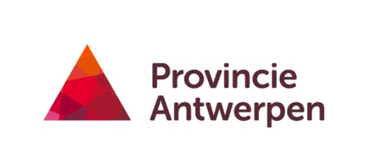

COST Action FA1404
Educational & Practitioner Workshop 1
Poultry Red Mite
The first COST FA1404 workshop was held in Geel (Belgium) on 23rd June 2015.
The workshop was organised by the Experimental Poultry Centre from the Province of Antwerp.
There were 21 participants, mostly researchers from 10 different countries (Belgium, UK, Sweden, Poland, Czech Republic, Spain, Italy, Portugal, France, Israel). 48% of the participants were early stage researchers and a gender balance was respected (52% female, 48 % male). There were also male and female speakers on the workshop.
Content of the workshop
- The participants were welcomed by the director of the Experimental Poultry Centre Johan Zoons.
Johan Zoons gave a short presentation of the research facilities and the core business of the Experimental Poultry Centre.

- Poultry Red Mite General information - Olivier Sparagano
Olivier Sparagano presented a general overview of de current knowledge of the poultry red mite from life cycle to treatment techniques. The need for effective and low cost preventive and curative methods was expressed.

- Ecology, dispersal routes and population dynamics – current knowledge and monitoring tools – Lise Roy
In this presentation the difference between the Northern Fowl Mite and the Poultry Red mite was highlighted together with spread patterns of the PRM worldwide and on the farm. Also, the Simplified Passive Trap (‘tape trap’) was explained.

- Monitoring Mite Monitoring System – Ellen Vervaet
The detailed method of the Mite Monitoring System was given.

- Monitoring techniques in practice – Lise Roy, Nathalie Sleeckx, Ellen Vervaet
The layerhouse of the EPC was ideal for an introduction of different monitoring techniques in practice. In furnished cages and in two types of aviaries 4 monitoring techniques (tape trap, MMS, PVC pipes with cardboard and water traps) were demontrated. The predilection places and expected spreading routes were discussed in detail.

- Mite handling – Lise Roy
Lise Roy gave an interesting demonstration of the morphological differences of Dermanyssus gallinae and Ornithonyssus sylvarium. The participants were able to look for these differences using light microscopes. In addition, choice tests and response tests were demonstrated and explained.

- General discussion – chair: Johan Zoons
The importance of an easy accessible platform for PRM information was expressed. The upcoming workshop in Montpellier in October was discussed.

Local Organisers:
Johan Zoons – Experimental Poultry Centre
Nathalie Sleeckx – Experimental Poultry Centre

