


Producers and scientists: working together to achieve better poultry red mite control
Controlling poultry red mite is one of the more difficult practical challenges the egg industry faces. In a current climate of legislative and consumer-driven changes to layer systems, changes in poultry management practices and the banning of many pest-control products; strategies for poultry red mite control are rapidly evolving out of necessity. A European Co-operation in Science and Technology (COST) initiative aimed at improving current understanding of, and research for, sustainable control of the poultry red mite (COREMI) is undertaking a survey of egg producers across the EU. In order to achieve one of the goals of the COST action, identifying the best practices to improve health, welfare and productivity of the laying hens through a more effective prevention and control of poultry red mites, we need up-to-date information from egg producers on poultry red mite control practices in use in the UK and throughout the EU. To that end, we would like to invite commercial egg producers with a flock of 1000 or more hens to participate in a short, confidential questionnaire that will be analysed on a UK basis and as part of a wider EU project. The questionnaire can be completed in paper form and returned by post to the Moredun Research Institute (address given on the survey) or in electronic form using the online BOS survey.

The aims and benefits of the survey include:
- Identify the best integrated pest management (IPM) practices currently in use in the UK and across the EU and disseminate that information to the producers to help improve productivity, health and welfare of laying hens. Best practice will be determined from producer experience given in the questionnaire responses and combined with the most up-to-date scientific findings and consultation with industry. The questionnaire will address several gaps in poultry red mite knowledge, including:
  - Are some production systems better for mite control? If so which are they?
  - What types of red mite controls are currently in use?
  - What combinations of controls provide the best mite control in commercial systems?
  - Do producers use threshold indicators (e.g. visual assessment of poultry red mite infestations, egg production data, mite monitor traps etc) to decide when to begin mite control treatments? If so what are the treatment threshold indicators in use, and can these be improved for better mite control?

- Updating the poultry red mite prevalence data for the UK. The latest prevalence data published for the UK is over 7 years old and based on survey data carried out prior to the conversion of battery systems to the enriched/colony cages. It is important have accurate and current data to assess the scale of the poultry red mite problem in the UK, and to evaluate what effects legislative changes are having on the poultry red mite prevalence.

- Establishing whether mite infestation impacts on the productivity in commercial situations and to gather some preliminary data on the financial costs associated with red mite infestation and control. Having up-to-date cost figures is important to highlight the economic damage red mite has on the egg industry. Current estimates are more than 10 years old and there is anecdotal evidence that costs have increased markedly in that time.

- Foster closer collaborative links between industry and scientists to support future research into improving red mite control and maintaining research relevance to industry.
The findings of the questionnaire will be reported to stakeholders and researchers using a variety of media including: farming and scientific press, producer association’s press release/websites and at meetings. It is envisaged that identification and the reporting of the best integrated pest management practices for poultry red mite control will be of direct benefit of the producers, by supporting improvements in egg production and hen welfare. The remaining three aims (prevalence, costs and collaborative links), will update, strengthen and consolidate existing knowledge, to provide supporting evidence of the serious impact of poultry red mite has on the UK and EU egg industries. Up-to-date knowledge will stimulate further research in red mite control, can be used to support applications for research funding and provides evidence for farming policy makers.

The poultry red mite is a persistent problem
The poultry red mite (also known as Dermanyssus gallinae, red mite, chicken mite and fowl mite) is a small blood-feeding parasite that lives in the cracks and crevices of the poultry house and furniture. These parasites generally emerge in darkness to feed on the blood of roosting hens every 3 or 4 days. Feeding is completed quickly, usually in less than 1 hour, and the mites return to the crevices where they aggregate together to digest their blood meal, mate and lay eggs. The blood-feeding stages of poultry red mite can survive for up to 9 months without a blood meal and can therefore persist for prolonged periods when the laying sheds are empty. In ideal conditions, the poultry red mite can complete its life cycle (from an egg to a reproductively mature adult) in just 7 days, and a female can lay several clutches of eggs, amounting to 30-50 eggs in her lifetime. In warm and humid conditions, mite population numbers can rise quickly to what is considered to be a moderate level of mites in commercial laying facilities of approximately 50,000 mites per hen. In these conditions, when mite controls are ineffective or not applied, mite numbers can explode to in excess of 0.5 million mites per hen and birds can suffer weight loss and become anaemic, directly causing an increase in hen deaths or increasing susceptibility to other avian diseases. Even at lower levels, poultry red mites can impact on the health and welfare of birds, causing stress, irritation feather pecking, poor plumage, increased cannibalism and reduced egg production and quality. At low infestation levels, mites can be difficult to find. A careful examination of the joints and crevices of poultry equipment, on the underside of bevelled perches or under caked manure may reveal small aggregates of mites. As mite number increase, large aggregations of mites can be seen on the open sides of poultry furniture. Poultry workers may start to complain of irritation caused by crawling mites and they may suffer from allergic dermatitis cause by mite contact and bites.
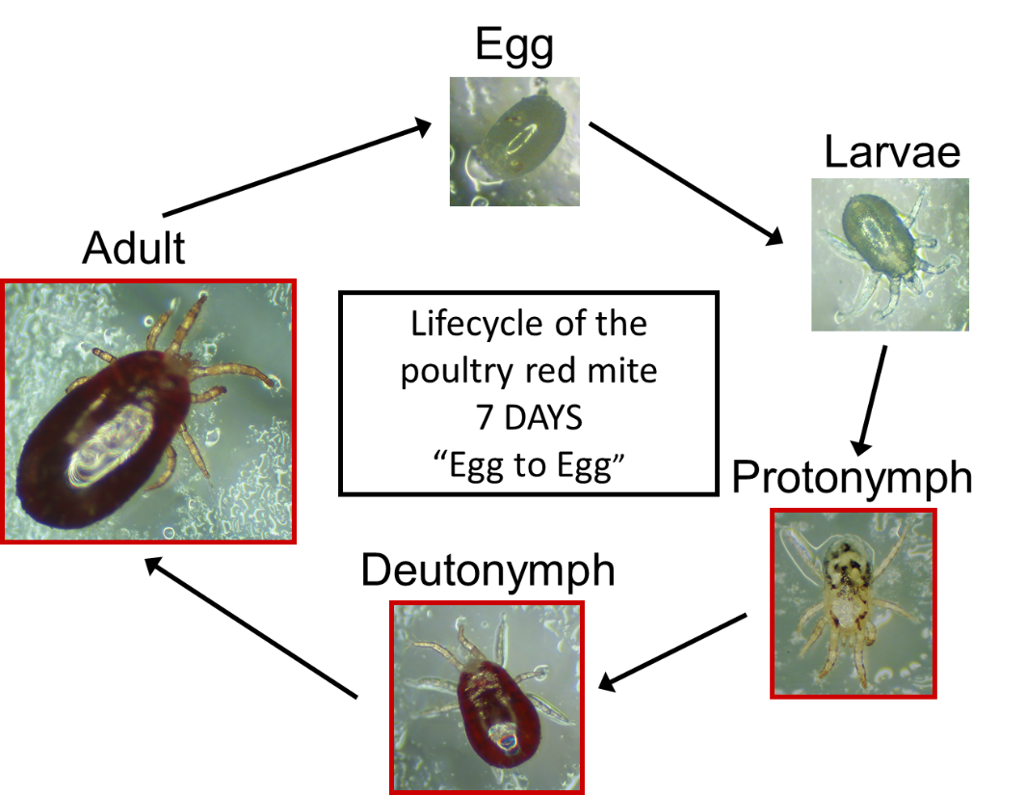

To maintain a standard of health and welfare of laying hens and poultry workers and to reduce the economic impact of red mite on egg production, it is usually necessary for farmers to use some form of control to reduce the infestation burden. Hygiene practices (e.g. manure removal and washing with detergents/degreasers) and synthetic chemical acaricides (e.g. carbamates, pyrethroids and organophosphates) are the traditional choice of treatments in the UK. Proper application of acaricides is essential, as they must directly contact the mite to be effective and this can be difficult to achieve when mites are hiding deep in the crevices of poultry house furniture or under build-ups of dust and manure. However, evidence suggests that if hygiene treatments are employed prior to acaricide spraying, a greater efficacy of treatment can be achieved. Acaricide usage is subject to tightening legislation and many of the previously effective acaricides are now either banned, not licensed for use in poultry premises or not licensed specifically for red mite control. In addition, a survey of British egg laying producers carried out in 2004 indicated than 60% believed that they had experienced acaricide-resistant infestations. The potential for reduced acaricide effectiveness and reduction in legally available treatment options means farmers must continually search for, and try new treatments.

Application of desiccant dusts or liquid silica are also now common control practices in the UK, however these can be labour-intensive and some producers report that they can be stressful to the birds. A number of new controls are emerging however it is not yet clear how widely these are used in the commercial sector in the UK. Some treatments which are added to drinking water (e.g. such as cider vinegar and garlic extract (Breck-a-sol)) are reputed to act as mite repellents. New products based on potent essential oils (e.g. thyme and oregano) or fungi/plant derived products (e.g. Spinosad product Elector®, Neem oil product Mite-stop®) have shown promising results in the field, however as with synthetic acaricides, correct application is essential and they may be subject to regulatory approval. In parts of the EU, prolonged shed heating between flocks is a widely used control strategy and, when used correctly with appropriate biosecurity, can eradicate red mite in the following flock. New treatments are continuously emerging onto the market, for example feed additives (e.g. NoReds, Zoomite) and predatory mites; again it is unclear if these new products are widely used in the commercial sector in UK or other EU countries. There are several novel controls currently in development and these may have promise for future control. These include vaccines, fungi that kill the mites, electrified perches (Qperch), pheromones and intermittent lighting regimes.

The economic impact of poultry red mite on the commercial egg farmer.
The reported impact of poultry red mite on the egg laying industry includes flock mortality, decrease in egg production and egg quality and a lower feed conversion ratio. In addition, poultry red mite has been shown to be capable of mechanically transmitting a number of commercially important avian diseases such as avian influenza and Salmonella and may have implication for the spread of disease within a flock or between flocks. Therefore it is essential that poultry red mite numbers are controlled by farmer intervention. It is difficult to estimate the financial impact on farmers because of the complexity of the mite problem and the difference in costs associated with different layer systems. Calculations based on survey data gathered in the Netherlands in 2010 estimated the cost of red mite per hen was 0.43 Euro (an average figure for all layer systems in operation in the Netherlands). This figure was based on survey responses indicating that 0.29 Euro was accountable to production loss (feed conversion, hen mortality, reduced egg output/quality) and 0.14 Euro to mite control costs. It is likely that these costs are underestimated due to the time elapsed since the survey and the changes in layer housing and husbandry practices. To date, there has been no comprehensive cost analysis carried out for poultry red mite in the UK.
The difficulties in the battle to control red mite may be further exacerbated by, for example, increased farming intensity, the shift toward organic and cage-free production and legislation reducing the legal options for mite control. It is important to understand the impact of these changes on the egg industry in order to be able to react appropriately.

